Answers to questions in

Lab 2: Edge detection & Hough transform

Name: _____________Simon_Lagerqvist___________ Program: _____tiedb_______________________

**Instructions**: Complete the lab according to the instructions in the notes and respond to the questions stated below. Keep the answers short and focus on what is essential. Illustrate with figures only when explicitly requested.

Good luck!

___________________________________________________________________________

**Question 1**: What do you expect the results to look like and why? Compare the size of *dxtools* with the size of *tools*. Why are these sizes different?

Answers:

*We expext differences to be enhanced. Becuse the sobel operator operates opon the differences in between the pixels. The differences becomes highlighted. An operator of 3x3 needs one extra pixel to the left and one extra pixel to the right in the x direction. The same is true for the y direction.*

___________________________________________________________________________

**Question 2**: Is it easy to find a threshold that results in thin edges? Explain why or why not!

Answers:

No it isn't easy since there is no clear compromise between only dettecting the edges, (no unecesarry infromation) and not removing edges we want. The histogram can help finding a good threshold since we can see different types of edges. We can see the occurrence of different pixel values in the histogram. Since we can se how many pixels of each value exists in the histogram, we will get a good picture on where to cutoff.

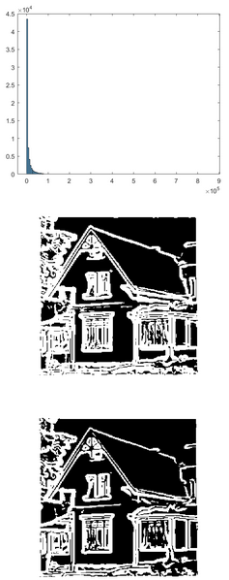 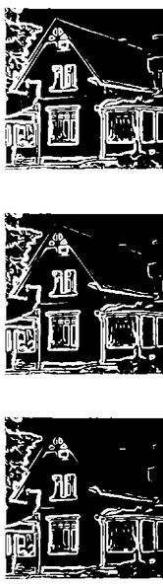

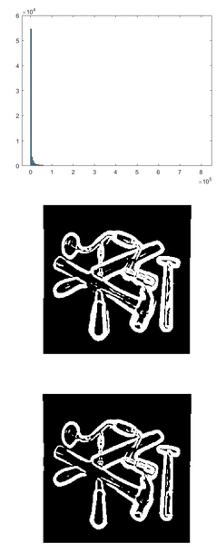 

___________________________________________________________________________

**Question 3**: Does smoothing the image help to find edges?

Answers:

smoothening the image helps finding edges since "details" which might contain edges aswell are removed prior to edge detection. This is since details are represented as high frequency information. There will be less edges detected when more smoothning are used.

___________________________________________________________________________

**Question 4**: What can you observe? Provide explanation based on the generated images.

Answers:

The third order derivative will allow us to separate between the edges based on the direction of the gradient, we will se the maximum points in the second derivative.

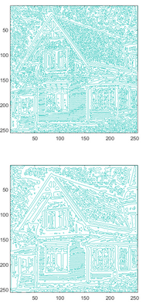 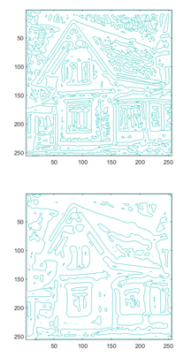 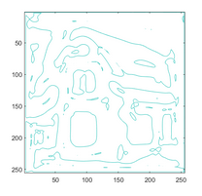

The image is quiete noisy since we have many zero corssings. For the

___________________________________________________________________________

**Question 5**: Assemble the results of the experiment above into an illustrative collage with the *subplot* command. Which are your observations and conclusions?

Answers:

We will have an edge where the second derivative is 0. This will be represented as a white area in the image. More smoothening results in wider white edges. We can the edges well in the third derivative.

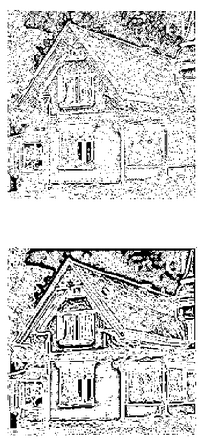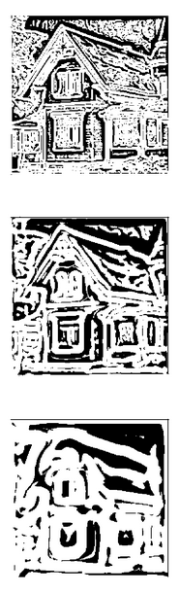

___________________________________________________________________________

**Question 6**: How can you use the response from *Lvv* to detect edges, and how can you improve the result by using *Lvvv*?

Answers:

We can look at the points were L~vv is 0 to detect edges

we know that we have an edge where the second derivative = 0 since the it means that we will have a maximum in the first derivative, which corresponds to an edge, the we use the third derivative to get only get the maximum points..

the problem with the second derivative is that minimipoints caused by spurious edges (noise) will be 0. These can be removed by looking at the third derivative

___________________________________________________________________________

**Question 7**: Present your best results obtained with *extractedge* for *house* and *tools*.

Answers:

Using parameters set to:

extractedge(house, 2, 6000)

extractedge(tools, 3, 6000)

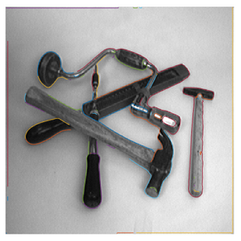 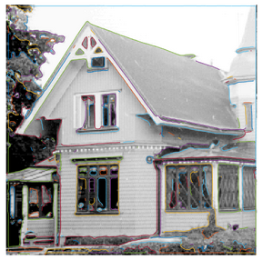

___________________________________________________________________________

**Question 8**: Identify the correspondences between the strongest peaks in the accu-mulator and line segments in the output image. Doing so convince yourself that the implementation is correct. Summarize the results of in one or more figures.

Answers:

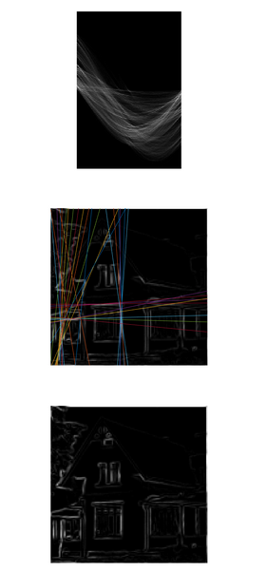 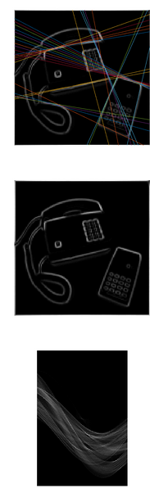 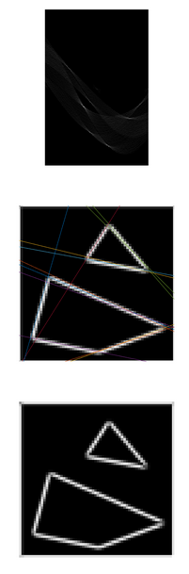

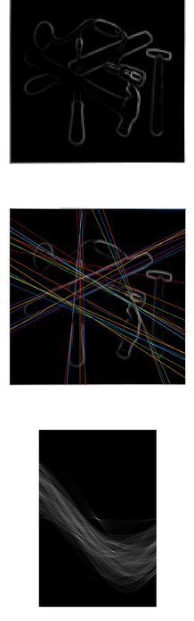

___________________________________________________________________________

**Question 9**: How do the results and computational time depend on the number of cells in the accumulator?

Results for the simple image using the MATLAB tic toc function

Answers:

|  |  |  |
| --- | --- | --- |
| theta | rho | sec |
| 100 | 100 | 0.554 |
| 1000 | 100 | 2.565 |
| 10000 | 100 | 20.136 |
| 100000 | 100 | 204.326 |
| 100 | 1000 | 0.608 |

We can observe that theta makes the biggest difference since it will increase the number of interations in the theta for loop.

We can se that as for increasingly large theta the time complexity should be approx.: O(N*theta)

___________________________________________________________________________

**Question 10**: How do you propose to do this? Try out a function that you would suggest and see if it improves the results. Does it?

Answers:

When using +1, edges will be prioritized based on their length, since a long edge will have more points and give a bigger value in the accumulator matrix. When we use the gradiant, a “stronger” edges will be prioritized instead.

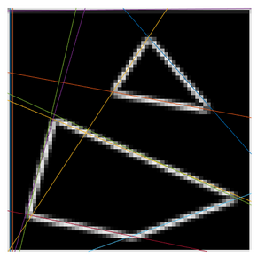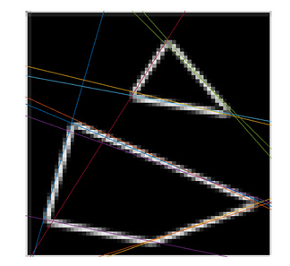

We can see that the frame edge isn’t detected using the gradient magnitude as our summation variable.



The function h will decide how much we will consider the gradient magnitude relative to the length of the image.

The prioritization of the width of the edge will be decided by the resolution of rho and theta

___________________________________________________________________________